COMSATS University Islamabad
Abbottabad Campus
Department of Computer Science
SPRING - 2026
Lab Midterm Exam

Class: | BSE-3A | Date: | June 16, 2026
Subject: | Data Structures (DSA) | Instructor: | Zulqarnain
Time Allowed: | 1.5 Hours | Total Marks: | 25 Marks

[CLO-4 – C3 | PLO-2: Problem Analysis | Bloom's: Apply] | (MARKS: 08)

Q1. Linked List – 8 Marks
Implement a singly linked list in Java that stores student roll numbers with the following operations:
a) insertAtBeginning(int data) – Insert a node at the beginning of the list. (2)
b) deleteByValue(int data) – Delete the first node that contains the given value. If the value is not found, print an appropriate message. (3)
c) printReverse() – Print all nodes in reverse order using recursion. Do not use any extra data structure or array. (3)

Answer :
package midlab;

class Node {

int data;
Node next;

Node(int data) {
this.data = data;
next = null;
}
}

class LinkedList {

Node top;

void insertAtBeginning(int data) {

Node node = new Node(data);

node.next = top;

top = node;
}

void deleteByValue(int data) {

if (top == null) {
System.out.println("List is empty");
return;
}

if (top.data == data) {
top = top.next;
return;
}

Node temp = top;

while (temp.next != null && temp.next.data != data) {
temp = temp.next;
}

if (temp.next != null) {
temp.next = temp.next.next;
} else {
System.out.println("Value not found");
}
}

void printReverse() {
printReverse(top);
System.out.println();
}

void printReverse(Node node) {
if (node == null) {
return;
}

printReverse(node.next);
System.out.println(node.data + " ");
}

}

public class Midlab {

public static void main(String[] args) {

LinkedList list = new LinkedList();

list.insertAtBeginning(101);
list.insertAtBeginning(102);
list.insertAtBeginning(103);
list.insertAtBeginning(104);
System.out.println("Before Delete ");
list.printReverse();
list.deleteByValue(102);

System.out.println("After Delete ");

list.printReverse();
}
}

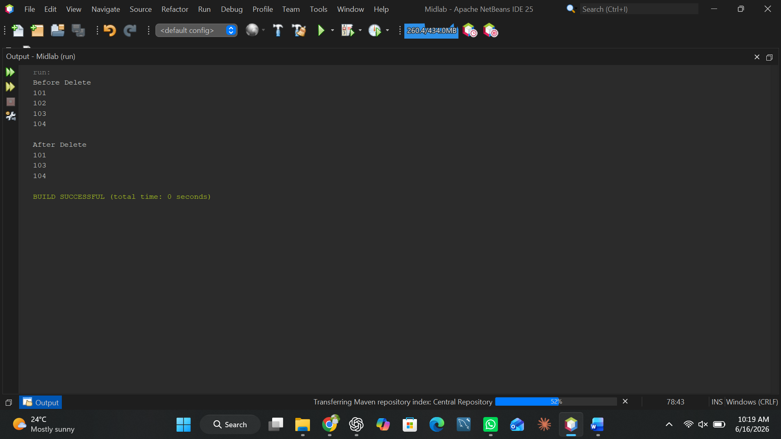

[CLO-4 – C3 | PLO-2: Problem Analysis | Bloom's: Apply] | (MARKS: 09)

Q2. Stack – 9 Marks
a) Implement a Stack using an array with push(), pop(), and peek() operations. Handle stack overflow and underflow with appropriate messages. (3)
b) Using your stack, write a method that converts an infix expression to postfix.
Example: P*(Q+R)-S/T → PQR+*ST/- (3)
c) Evaluate the following postfix expression step by step (show stack trace in comments):
5 1 2 + 4 * + 3 - (3)

Answer :
package ds_midlabq2;

class Stack {

char[] stack = new char[50];
int top = -1;

void push(char data) {

if (top == stack.length - 1) {
System.out.println("Stack Overflow");
return;
}

stack[++top] = data;
}

char pop() {

if (top == -1) {
System.out.println("Stack Underflow");
return '0';
}

return stack[top--];
}

char peek() {

if (top == -1) {
return '0';
}

return stack[top];
}

boolean isEmpty() {
return top == -1;
}

static int precedence(char ch) {

if (ch == '+' || ch == '-') {
return 1;
}
if (ch == '*' || ch == '/') {
return 2;
}

return 0;
}

static String infixToPostfix(String infix) {

Stack s = new Stack();
String postfix = "";

for (int i = 0; i < infix.length(); i++) {

char ch = infix.charAt(i);

if (Character.isLetterOrDigit(ch)) {
postfix += ch;
} else if (ch == '(') {
s.push(ch);
} else if (ch == ')') {

while (!s.isEmpty() && s.peek() != '(') {
postfix += s.pop();
}

s.pop();
} else {

while (!s.isEmpty() && precedence(s.peek()) >= precedence(ch)) {
postfix += s.pop();
}

s.push(ch);
}
}

while (!s.isEmpty()) {
postfix += s.pop();
}

return postfix;
}

static int evaluatePostfix(String expr) {

int[] stack = new int[50];
int top = -1;

for (int i = 0; i < expr.length(); i++) {

char ch = expr.charAt(i);

if (ch == ' ')
continue;

if (Character.isDigit(ch)) {
stack[++top] = ch - '0';
} else {

int b = stack[top--];
int a = stack[top--];

int result = 0;

switch (ch) {

case '+':
result = a + b;
break;
case '-':
result = a - b;
break;
case '*':
result = a * b;
break;
case '/':
result = a / b;
break;
}

stack[++top] = result;
}
}

return stack[top];
}
}

public class DS_midLabQ2 {

public static void main(String[] args) {

System.out.println(Stack.infixToPostfix("P*(Q+R)-S/T"));
System.out.println("Postix Evaluation");
System.out.println(Stack.evaluatePostfix("5 1 2 + 4 * + 3 -"));
}
}
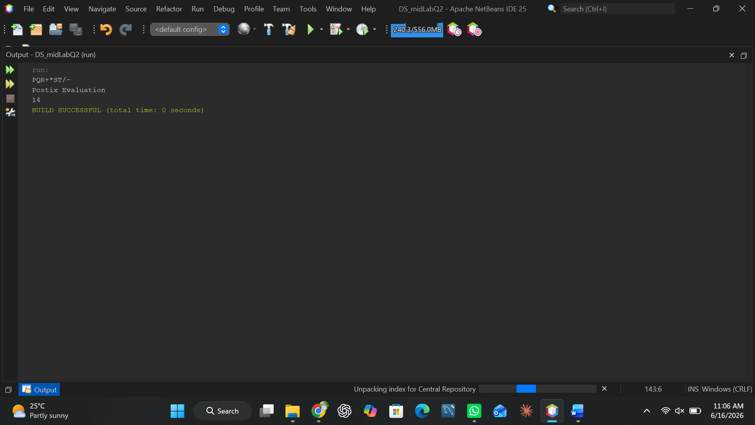

[CLO-4 – C3 | PLO-2: Problem Analysis | Bloom's: Apply] | (MARKS: 08)

Q3. Queue – 8 Marks
a) Implement a Circular Queue using an array with enqueue(), dequeue(), and display() operations. Handle queue full and empty conditions with appropriate messages. (5)
b) A hospital patient queue receives patients in this order: P1, P2, P3. P1 is attended and removed. P4 and P5 are added. P2 is then attended and removed. P6 is added. Simulate this scenario using your circular queue and print the queue state after each step. (3)
Answer :
package ds_midq3;

class CircularQueue {

String [] queue = new String[5];
int front = -1;
int rear = -1;

void enqueue(String value) {

if ((rear + 1) % queue.length == front) {
System.out.println("Queue is Full");
return;
}

if (front == -1) {
front = 0;
}

rear = (rear + 1) % queue.length;
queue[rear] = value;

System.out.println(value + " inserted");
}

void dequeue() {

if (front == -1) {
System.out.println("Queue is empty");
return;
}

System.out.println(queue[front] + " removed");

if (front == rear) {
front = rear = -1;
} else {
front = (front + 1) % queue.length;
}
}

void display() {

if (front == -1) {
System.out.println("Queue is empty");
return;
}

int temp = front;

while (true) {
System.out.print(queue[temp] + " ");
if (temp == rear) {
break;
}
temp = (temp + 1) % queue.length;
}

System.out.println();
}
}

public class DS_midQ3 {

public static void main(String[] args) {

CircularQueue q = new CircularQueue();

System.out.println("Step 1");
q.enqueue("P1");
q.enqueue("P2");
q.enqueue("P3");
q.display();

System.out.println("Step 2");
q.dequeue();
q.display();

System.out.println("Step 3");
q.enqueue("P4");
q.enqueue("P5");
q.display();

System.out.println("Step 4");
q.dequeue();
q.display();

System.out.println("Step 5");
q.enqueue("P6");
q.display();
}
} 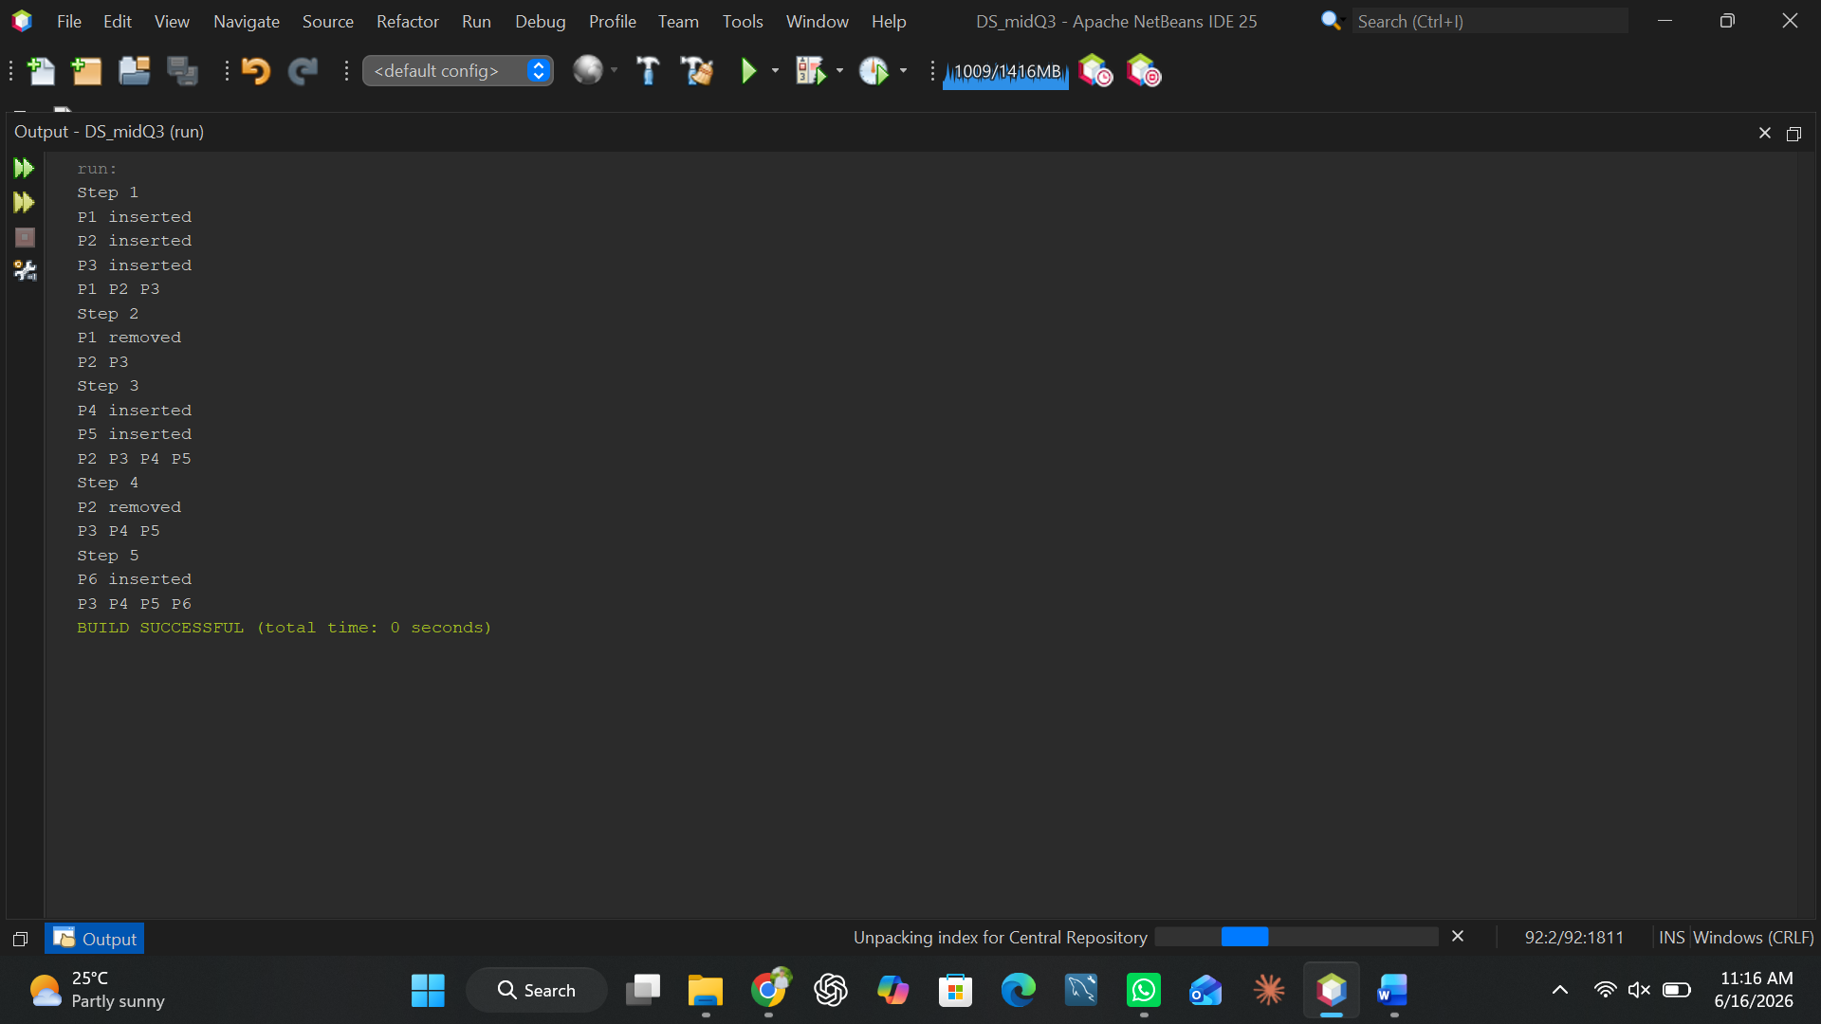

Group Member’s :
- Muhammad Noor (SP25-BSE-007)
- Rukhsar Bano (SP25-BSE-011)
- Muhammad Asim (SP25-BSE-035)
- Mateen Haider (SP25-BSE-108)
*** END OF PAPER ***

